V5 Shakespeare project
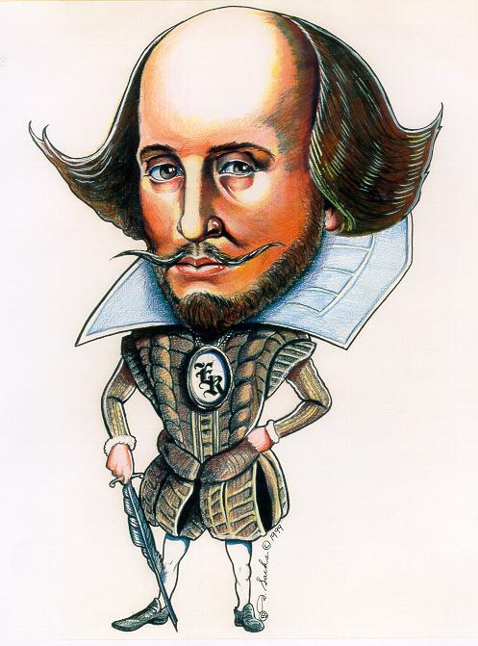

To be or not to be
...
What was the question?

Next to a writing test (3x), you are going to do the Shakespeare Project (2x) in teams. Your group will need a team name. You will collect stamps on a stamp sheet by doing various assignments. These stamps will form your grade for the Project. You have to fill in a progress sheet to show you deserve the stamps.
Each week you will do 2 compulsory (!) assignments about Shakespeare and about Macbeth. These will be followed by optional (?) assignments and the week will be closed with a finishing up (√) assignment.
If you look at your stamp sheet you will see that …
…You will get 1 stamp for 2 correct ! assignments (6 total)
…You will get 1 stamp for 1 correct ? assignment (? total)
…You will get 1 stamp for 1 correct √ assignment (6 total)
Two tips:
Make use of your group members’ strong points.
Plan smart to get the maximum amount of assignments done.

Planning

Week 1 Shakespeare’s time . . . . . p. 3
Macbeth’s plot

Week 2 Elizabethan drama . . . . . p. 5
Macbeth’s characters

Week 3 Shakespeare’s plays and The Globe . . p. 7
Macbeth: your opinion

Week 4 Shakespeare’s sonnets . . . . . p. 9
Macbeth analysis

Week 5 Shakespeare’s problem . . . . . p. 12

Week 6 Shakespeare’s competition . . . . p. 13


! Assignment week 1: Shakespeare’s time

Did you know that Shakespeare laid the basis for modern drama? And where do you think movies come from?

- One of you is going to find out when and where Shakespeare lived and what this period in time was called.
- One of you is going to find out which institutions ruled the country.
- One of you is going to find out when and where the Renaissance began and how it spread.
- One of you is going to find out what characterised art and literature in the Renaissance.

Fill in on your progress sheet who is going to do what!

You now know something about the time in which Shakespeare lived. Brainstorm in your group about how you think elements of his time could show in his works. Think of at least 4 elements. Put your answers on your progress sheet.

! Assignment week 1: Macbeth game and plot

- Do the Macbeth game in class.
- Everyone reads one part of the Macbeth plot, indicated with O, ☻, ♫ or ■ in silence.
- Put the pieces of the story in the correct order on your progress sheet.
- Make a character web: write down the names of all the characters in the play and put Macbeth in the middle. Connect the names to each other and indicate how they are connected. For instance: Lady Macbeth → ♥ →Macbeth.
- Choose two of the following questions and try to answer them.
  - Every story has at least one climax. Where is the climax according to you?
  - When do you think things started to go wrong for Macbeth?
  - Is there a moral? If so, what do you think is the moral of this story?
  - What do you think of the women in the play?
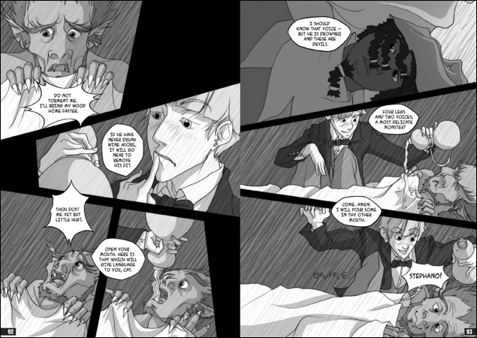
Which team has won the Macbeth game?

? Optional assignments week 1
All of these assignments can be done alone or in a group. They have to be handed in -or acted out- no later than in the third week!

@ Prepare your own version of a Macbeth scene. This may be in prose or drama and you could write it on paper or act it out. Pick at least one of the following settings:
- high school
- family
- gangster organisation/mafia
- list continues on next page !-
- film set
- sports/dancing club or
- a supermarket
- in the future
- on a talk show

© Write your own (manga) comic of Macbeth. Make sure that emotions of the characters are clearly visible and that there is a reasonable amount of text, or your team will not receive the stamp. Hand in your comic no later than in week 3.
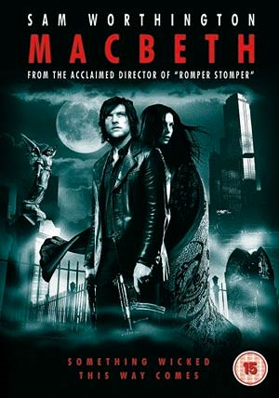
Ө Make a modern film poster for Macbeth. Pay attention to actors, décor and style. Be creative! You may use the computer, magazine or other clippings, paint, etc. Hand in your poster no later than in week 3.

☺☺Prepare to act out a scene. Pay attention to positions on stage, emotions, tension etc. Your scene has to be acted out no later than in week 3.

- Finishing up week 1: Shakespeare’s time and Macbeth’s plot

Which Renaissance elements can you find in Macbeth? Fill your answer in on your progress sheet and also very important: give examples!

Finished with these assignments?
Don’t forget to hand in your stamp sheet for stamps!
☺ ☺ ☺
! Assignment week 2: Elizabethan Drama

Jim Carrey as Bruce in “Bruce Almighty” to God: “Where are you going?”
God: “I’m taking a vacation.”
Bruce: “God doesn’t take vacations. Does he?... Do you?...”
God: “Did you ever hear of the dark ages?”

- Two of you are going to find out what the status was of the theatre in the Elizabethan period and how it changed in the Elizabethan era.
- Two of you are going to research the medieval story ‘Everyman’. What is the plot and what is the moral?

Fill in on your progress sheet who are going to do what!

Together you will answer the following questions.
- What is the difference between the Middle Ages and the Renaissance for the individual?
- How is this difference reflected in ‘Everyman’ and ‘Macbeth’?
- Now that you know this, why was Shakespeare so important at that time?

! Assignment week 2: Macbeth - characters

- Everybody read Act 1, scene VII.
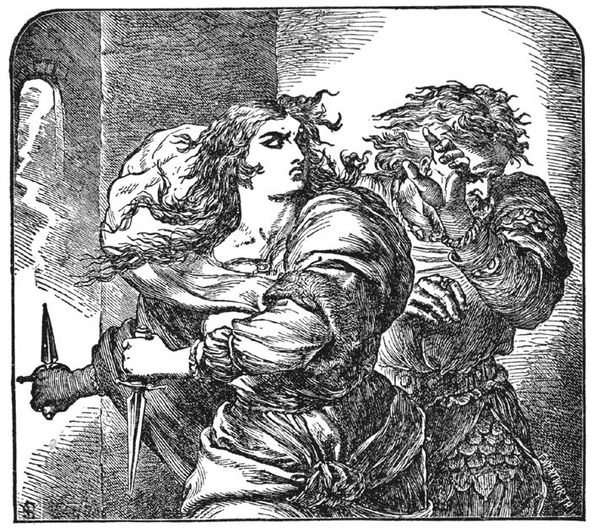
  - Two of you are going to write down 4 character traits that describe Macbeth. Fill these in on your progress sheet.
  - Two of you are going to write down 4 character traits that describe Lady Macbeth. Fill these in on your progress sheet.
- In your group answer the following questions about the scene you have read on your progress sheet:
  - Who is smarter? And WHY?
  - Who is emotionally more stable? WHY?
  - Who is going to do the act?
  - What preceded the decision to kill Duncan?
- In your group, discuss those 4 character traits you now have for Macbeth and decide which one suits him best.
- Now on your progress sheet fill in your character trait in the first place in the following sentence: Isn’t it _________ that Macbeth _______________? Fill in a typical situation/decision/occasion of the play that fits on the second line.

? Optional assignments week 2

Indicate on your team’s progress sheet which optional assignments you will do!

> Make a division between major and minor characters in the play.
@ Imagine you are (Lady) Macbeth and you are writing in your diary. What has happened and what do you think of all that? Remember that she does not see the end of Macbeth.
Ө Design clothes for one (or all) of the characters in the play.
♫ Write a love song for Lady Macbeth as Macbeth.
© Would you have done the same in (Lady) Macbeth’s place? Write in at least 200 words why or why not.
☺-☺Imagine you had the chance to have an in-depth interview with Shakespeare himself. What would you ask? Get somebody to try to answer your questions.

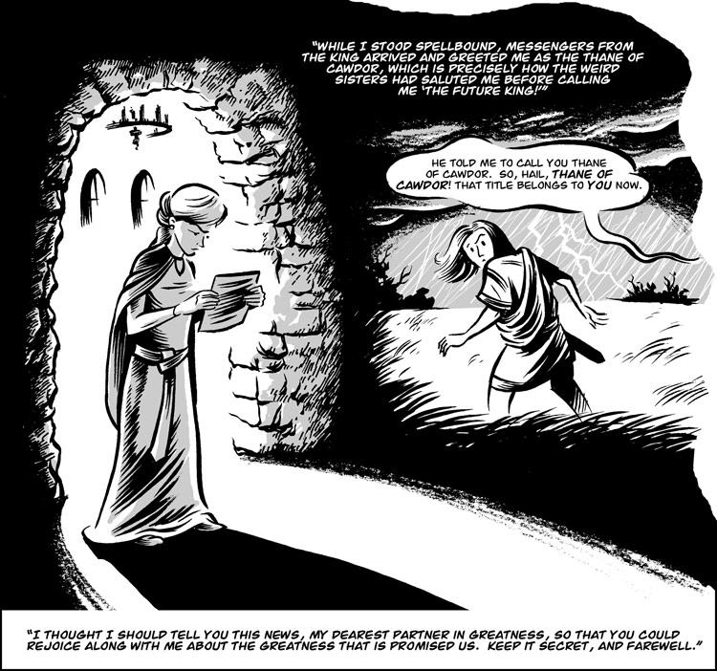

- Finishing up week 2: Shakespearean plays and Macbeth’s characters
If you could choose, who would you rather be? Everyman or Macbeth? And why? If there are different opinions in your group, try to convince each other of the best choice. Fill in on your progress sheet what the outcome is.
Finished with these assignments?
Don’t forget to hand in your stamp sheet for stamps!
☺ ☺ ☺
! Assignment week 3: Shakespeare’s plays and The Globe

“To be, or not to be, that is the question…”- What play was that and what does it mean?

- One you will find out what the Globe is, what it has to do with Shakespeare and what his first play in the Globe was.
- One of you will read a synopsis of this play and why the Globe moved from one side of the Thames to the other side of the Thames.
- One you will make an overview of the three major categories of plays he wrote, one of which was ‘comedy’
- One of you will try to get an impression of what plays in “The Globe” were like then (actors, audience, seating, equipment and props etc.).

Fill in on your progress sheet who is going to do what!
Also write down at least 3 sources you used.

Now in your group analyse the play you picked:
- What is the name of the first play?
- In which category does the play fit and why?
- What is the theme of the play?
- Can you make a comparison of this play and Macbeth? Write down at least 6 things in which the plays differ or are the same.
- Let’s take away the setting of a few centuries ago. Could the play today still be relevant?

! Assignment week 3: Macbeth – opinion

For yourself, try to answer the following questions in silence.
- What is the most frustrating moment in the play?
- What is the happiest moment in the play?
- To which character can you relate the most?
- When do you think is it okay to kill a king?
- What would audiences have thought of the play after they had left the theatre?

Now in your group, discuss your answers and come up with one group answer per question. Try to really convince the others of why your answer is the right one! Put your team’s answers on your progress sheet.

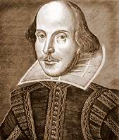
? Optional assignments week 3

Indicate on your team’s progress sheet which optional assignments you will do!

@ Write a review about Macbeth of at least 300 words that rich people in the 1600s would read. You may use modern English.
Ө If had to explain to your mother what you were doing in English class, what would you say about the play Macbeth? Act out your response to the class with a friend (‘mom’), turn it into a comic or write it down and hand it in.
♫ Write a song/rap/poem in which you express your opinion of Macbeth.
© Make a timeline of the plays of Shakespeare.
# Design a modern day book cover (AND back flip) for the play.
☻You are a book salesman/woman and you have to sell this book to a potential buyer. What would say to sell it? Act out your response to the class with a friend (‘buyer’), turn it into a comic or write it down and hand it in.

- Finishing up week 3: Shakespeare’s plays, The Globe and your opinion

In a day and age in which life wasn’t (allowed to be) all too jolly, can you understand why people would turn to Shakespeare’s plays? Give at least 4 reasons why people would pay a whole penny to go see his latest plays and put this on your progress sheet.

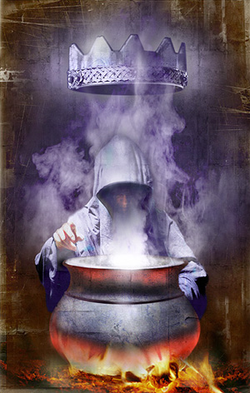

Finished with these assignments?
Don’t forget to hand in your stamp sheet for stamps!
☺ ☺ ☺
You should now have at least 6 !-assignment stamps.
Is your group running on schedule?

! Assignment week 4: Shakespeare’s sonnets

“Shall I compare thee to a summer’s day?” – Shakespeare in love? With whom?

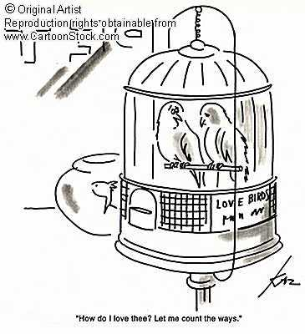
- One of you is going to find out what typifies a Petrarchan and a Shakespearean sonnet.
- One of you is going to find sonnet 20 by Shakespeare, look up the difficult words in the sonnet and try to understand it.
- One of you is going to find out how many sonnets Shakespeare wrote and what the main subjects were.
- One of you is going to find out to whom he wrote those sonnets and who he/she/it /they was/were to Shakespeare.

Fill in on your progress sheet who is going to do what!

Now in your group, answer the following questions and put them on the progress sheet.
- What is the rhyme scheme of sonnet # 20?
- Where is the volta? Write down the first two words of the volta.
- What kind of sonnet is this?
- What is the meaning of the sonnet?
- Do you like it? Why?
- To whom did he write this sonnet? How can you tell?
- Was there anybody else he would write sonnets for? Who?

! Assignment week 4: Macbeth – analysis

- Read Act II, scene II.
- Two of you will concentrate on Macbeth’s feelings.
- Two of you will concentrate on Lady Macbeth’s feelings.

Fill in on your progress sheet who is going to do what!

- Answer these questions and put your answers on your progress sheet.
  - What has just happened?
  - How does Macbeth feel?
  - How does Lady Macbeth feel?
- Now read Act V, scene I.
- Answer these questions and put your answers on your progress sheet.
- Who are present?
- What is happening?
- What is the impression you get from Lady Macbeth’s state of mind?

In Act II, scene I (the first part you have just read), Macbeth says:

Methought I heard a voice cry “Sleep no more! Macbeth does murder sleep.” The innocent sleep, sleep that knits up the ravell’d sleave of care, the death of each day’s life, sore labour’s bath, balm of hurt minds, great nature’s second course…

Now in your group try to answer these questions.
- What does Macbeth think of sleep?
- What does Macbeth think he has done to sleep?
- How can you find this back in Act V, scene I?

? Optional assignments week 4

Indicate on your team’s progress sheet which optional assignments you will do!

█ Make a time line of Shakespeare’s life (above the line) and works (below the line).
♣ Make a comic of the scenes you have read.
Ө Design a décor (possibly including actors) for one of scenes you have read.
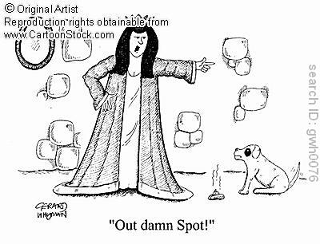
♀ Write a recipe for your own witches’ broth that is at least as disgusting as in the play.
Ф Act out at scene.
♫ Put a sonnet to music (or change it so you can rap it).
O Rewrite one of the scenes and make it modern.
♥ Make a list of words that Shakespeare ‘invented’ and which are still used today.
♂ Find out who Shakespeare had relations with in his life and write these down.

- Finishing up week 4: Shakespeare’s sonnets and Macbeth analysis

This week you’ve done some literary analyses. This can be very difficult so well done ☺!

In this week’s finishing up assignment you can choose whether you want a ‘normal’ finishing up assignment or a ‘difficult’ one. Which one are you going to do? Fill this in on your progress sheet!

Normal finishing up assignment:

Your group must now be able to answer the following question. Who did Shakespeare write sonnets to? Choose below and give the correct answer(s) on your progress sheet.
  - “the jealous mistress”
Do you think Shakespeare was in luuuuv?

  - “a fair youth”
  - “the grey gentleman”
  - “the dark lady”
  - “a luminous duke”
  - “the rival poet”

You should have quite an interesting answer on your progress sheet!
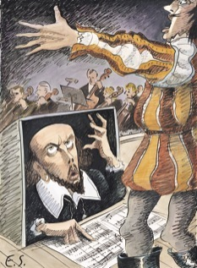
Is there more going on in Shakespeare’s plays and sonnets than frilly language?

Now pick a sonnet of your own, read it in your team and answer the following questions:
- Which sonnet did you pick?
- What is the rhyme scheme of the sonnet?
- What is the sonnet about?
- Where is the volta?
- Why is it the volta?
- To whom did Shakespeare write this sonnet?
- Why do you think so?
- Do you like the sonnet? And why (not)?
Don’t forget to put your answers on your progress sheet.

Difficult finishing up assignment:

Think along in your group by answering these questions. Put your answer to the last question (in italics) on your progress sheet!
- What have you learnt about actors and actresses in Elizabethan drama? (you should get this question right to be able to answer the next ones).
- How is this in line with Renaissance thinking (for hints, go see your teacher)?
- Shakespeare often plays with this idea by making ladies pretend that they’re men (i.e. in “A Midsummer night’s dream” and “The Merchant of Venice”). Why could this be funny on stage in his days?
- Where can you find this gender role tension in Macbeth? Remember, we are in 1605!
- Could there be another reason why Shakespeare would play with gender roles?

Finished with these assignments?
Don’t forget to hand in your stamp sheet for those stamps!
☺ ☺ ☺

◘ Let’s evaluate!

We have enjoyed Shakespeare for four weeks now and your team has done many assignments. Before we move on to our final assignment, let’s have a look at the project so far. Please answer the following seven questions in your team:

- Which assignment(s) did your team like best?
- Which assignment(s) did your team not like?
- How is the team work?
        - Does everybody pitch in?
        - Does everybody stick to agreements?
        - Is everybody’s work done in time?
        - Is there anything that could be improved?
- Do you like working with the progress sheet?
- Do you like working with the stamp sheet?
- Do you feel you have learnt anything? If so, what?
- Do you have any suggestions for us how to improve this project?

Please put your answers on your progress sheet.

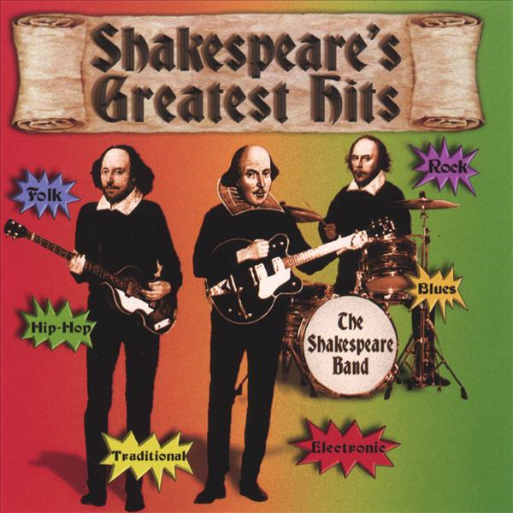

! Assignment weeks 5: Shakespeare’s problem

“Fair is foul, foul is fair” – Macbeth (Act I, scene I)

We’ve come to know the man, his life, his time and his works. He has been a major influence in modern drama, which in turn led to our modern movies. Some still consider Shakespeare the greatest playwright of them all, even 400 years after he died. The coming two weeks your team is going to try answer the following question:

Is Shakespeare who we think he is?

- Two of you are going to find what is (not) known about his life and why Shakespeare couldn’t be Shakespeare.
- Two of you are going to find out who said Shakespeare couldn’t be Shakespeare and what the names of the alternatives were if Shakespeare isn’t Shakespeare.

Fill in on your progress sheet who are going to do what!

In your team, you are going to make a poster of Shakespeare’s problem.
- Divide a large (minimum of A3) coloured page into two halves. One half says “Shakespeare = Shakespeare”, the other says he isn’t.
- Put your team name on top and what this international debate is called.
- Write down all the information your team has gathered on this page and in the correct half.
- Add pictures, drawings, arrows, et cetera to make your poster attractive.

Present your poster to your teacher for a stamp on your stamp sheet in English. Everybody in your team should be able to present the poster, so you teacher will appoint a presenter.

? Optional Assignments week 5

Any of the optional assignments of the previous weeks in the Shakespeare Project which have not yet been done by your team, may still be collected for stamps.

- Finishing up week 5: Shakespeare’s problem

In your team, write one short essay of 300 words about your team’s opinion on this debate. Do you think it’s a useless debate? Do you think it’s an exciting debate? Is this new information to you? Why should(n’t?) schools teach this? Did everybody in your team agree on these questions or were there differences of opinion? How did you try to solve these differences?

Make sure you show the process your team has gone through to write the essay!

! Assignment weeks 6: Shakespeare’s competition
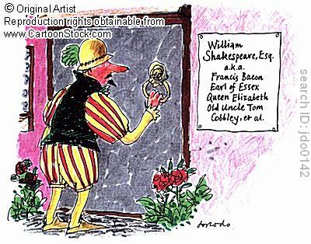
“What’s in a name? That which we would call a rose by any other name would smell as sweet.”
– Romeo and Juliet (Act II, scene II)

This week you are going to make a top 5 of possible candidates for Shakespeare and you are going to make advertisements for all of them. We will hang these in the class room and the team that has the most convincing advertisement gets an extra stamp!

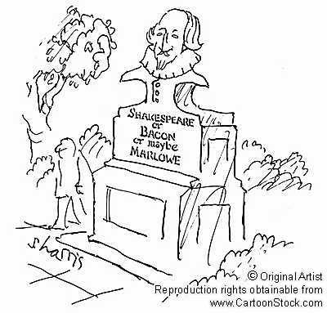
This has to be team work! What needs to be done?
- Your team needs to make an inventory of the possible candidates.
- Your team needs to list the pros and cons of each candidate.
- Your team needs to decide on the top 5.
- Your team needs to make a creative and appealing advertisement for this top 5.

Your public will be your classmates. Be as as you can! Yes, now craziness will get you points. You can either present your advertisement, act out your ad (on film or during class), make a poster, perform a song, give a statistical analysis of the possibility of some candidates, have a phone conversation with Shakespeare himself, whatever, as long as it’s crazy. And as long as it is no longer than 5 minutes.
Crazy

? Optional Assignments week 6

Any of the optional assignments of the previous weeks in the Shakespeare Project that have not yet been done by your team, may be collected for stamps.

- Finishing up week 6: Shakespeare’s competition

In your class, vote for the winning advertisement. And celebrate that your team have finished the Shakespeare Project.

Well done!

